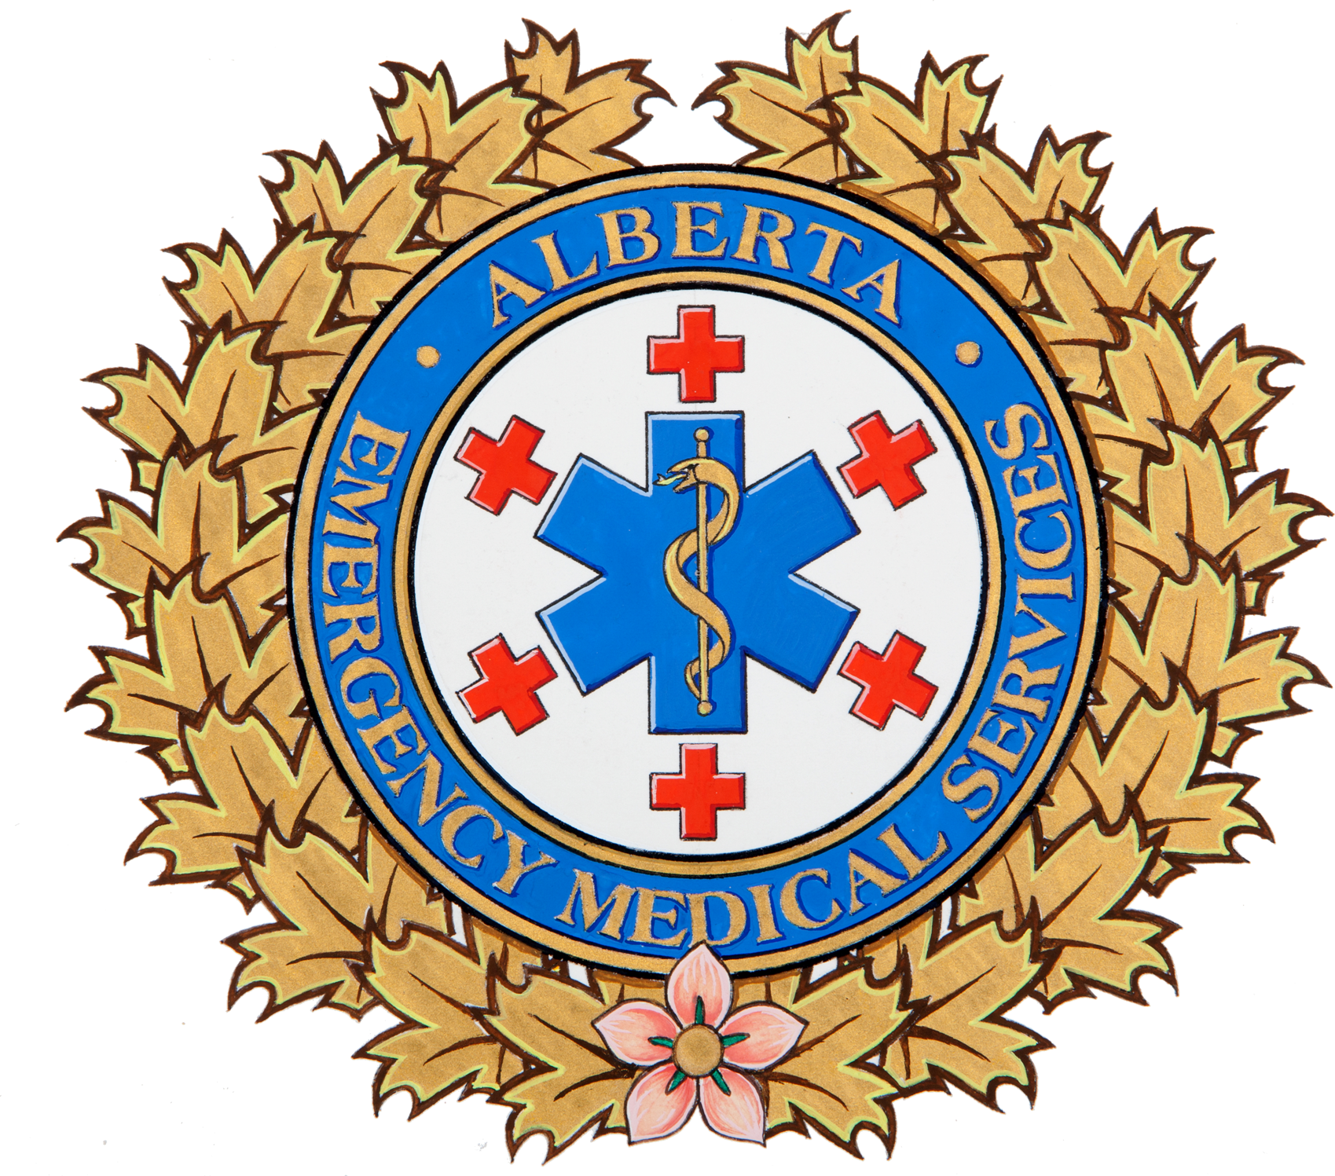

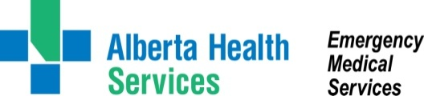

**February Is**

**Heart Month**

Do you know the signs and symptoms of a heart attack and what to do if someone experiences these? Knowing can make the difference between life and death. Recognizing and responding immediately to the warning signs of a potential heart attack can significantly improve survival and recovery.   
**February is Heart Month** - take the time to be heart safe and learn how you can reduce your risk.

**What to do when seconds count**

* Call 9-1-1 immediately. Early treatment can greatly reduce heart damage and make the difference of life and death;
* Treatment starts the moment EMS arrives. Paramedics can provide oxygen, start an intravenous and perform an electrocardiogram (ECG);
* Paramedics can also administer important medications in the early minutes of a heart attack to lessen heart damage;
* During transport, EMS will share information with the hospital, so definitive treatment can begin immediately on arrival;
* Take a CPR/AED (automated external defibrillator) course. Training is widely available from many reputable organizations. It’s easy, inexpensive, and only takes a few hours.

**Know the signs of a heart attack**

(Any or all of these signs & symptoms may occur)

* Chest pain described as crushing, squeezing, pressure or chest heaviness;
* Pain that moves beyond the chest such as shoulder, arm, neck or jaw;
* Shortness of breath, sweating or nausea and vomiting.

**Reduce your risk**

Heart attack risk factors include:

* Obesity*
* Sedentary lifestyle*
* Smoking*
* High cholesterol*
* Age / gender
* Family history

Speak with your doctor about how to treat your modifiable (*) risk factors and learn to be heart safe.



